**Assignment MT1-2020-4**

**Section 1**

**(Based on lecture notes)**

Note: - Use the notations used in the class whenever necessary

**Q.1.1)** What are the ways to obtain mass transfer coefficient?

**Q.1.2)** Derive an expression for mass transfer coefficient using following theories.

1. Film theory
2. Penetration theory
3. Surface renewal theory
4. Boundary layer theory

**Q.1.3)** Discuss how the flow of fluid associated with convective mass transfer is accounted for in the theories listed in Q.3

**Q.1.4)** Write the dimensionless numbers related to heat and mass transfer along with the physical significance of them

**Q.1.5)** Explain Reynolds’s analogy and Coulburn analogy.

**Q.1.6)** Explain different type of Mass Transfer Coefficient and develop the relationship among them.

**Q.1.7)** Provide the expressions for different type of Mass Transfer Coefficient for the following cases.

1. A is diffusing through non-diffusing B.
2. Equimolar counter diffusion.

**Section-2**

**(Based on the worked out problems in the text book)**

**From book: Principle of Mass Transfer by B.K.Dutta**

**Ex.3.1 Page no.79**



**Ex.3.2 Page no.80**

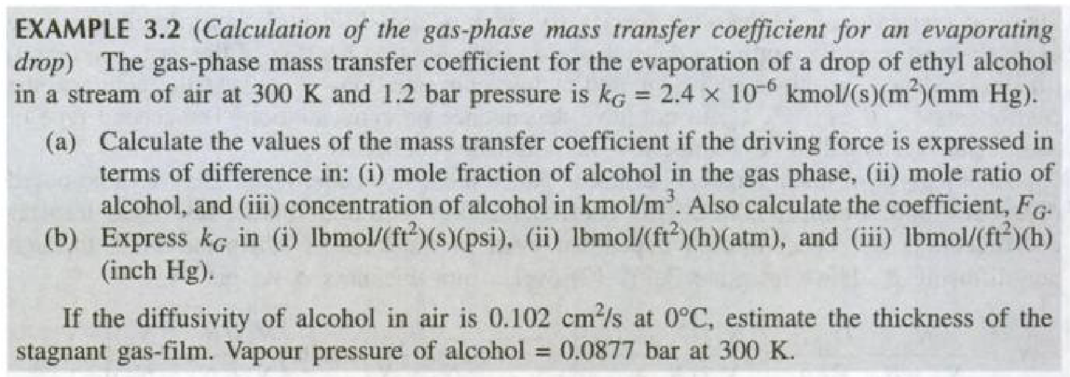

**Ex.3.3 Page no.87**

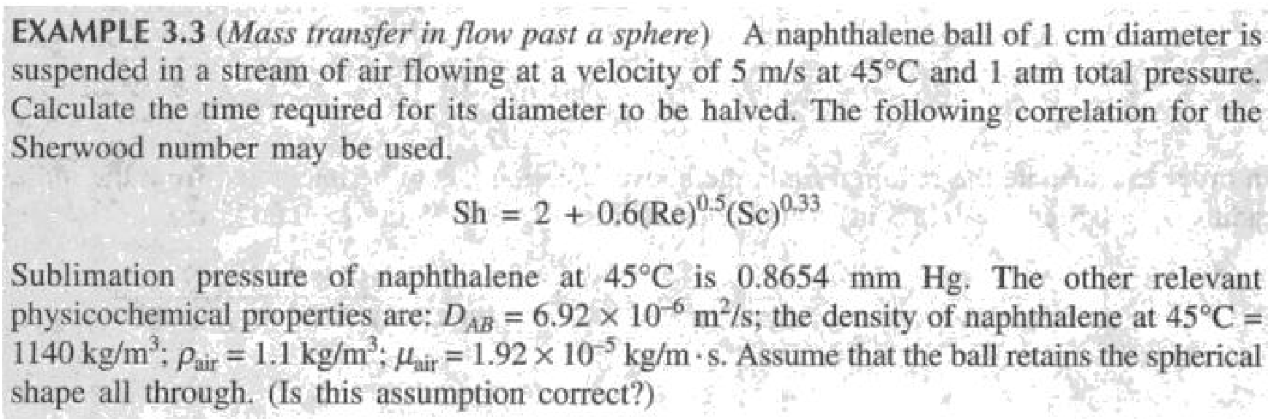

**Ex.3.4 Page no.89**

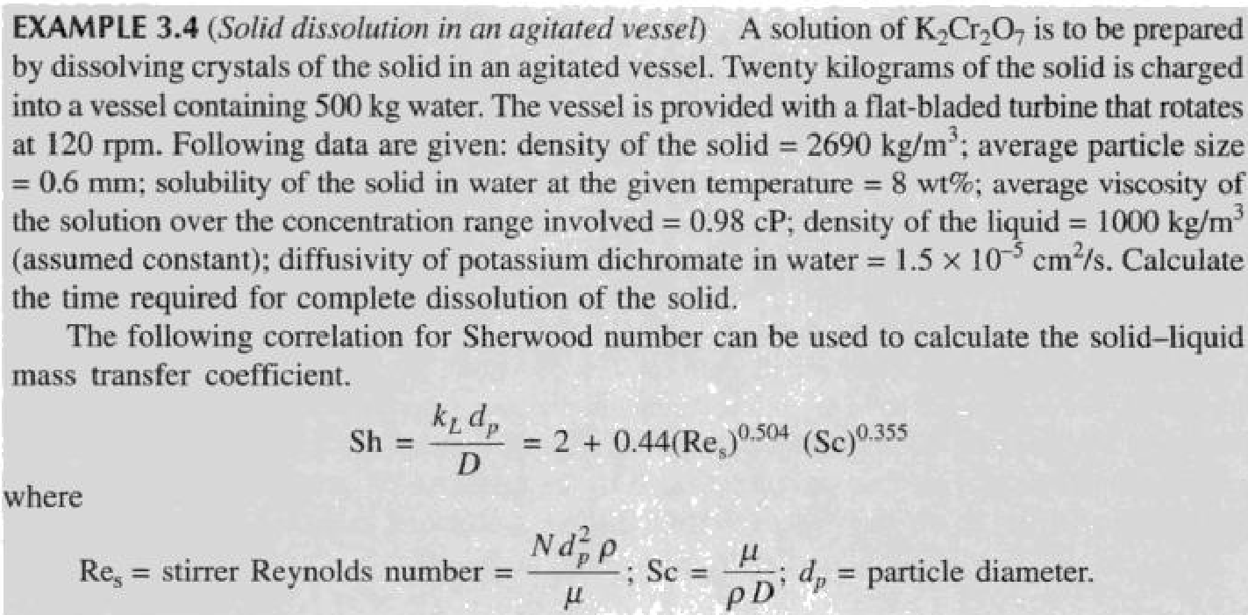

**Ex.3.5 Page no.99**

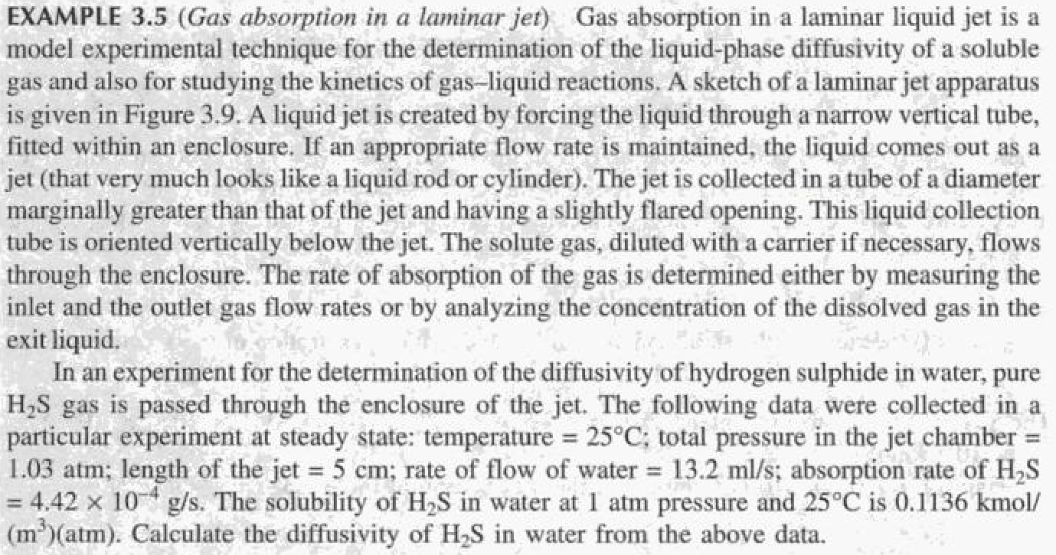

**Ex.3.6 Page no.100**

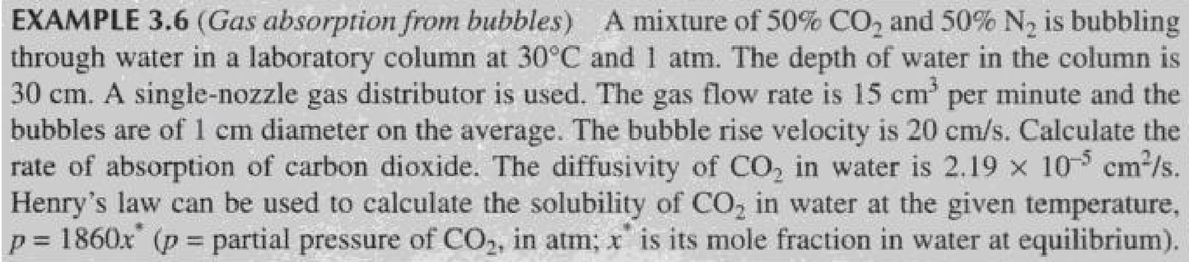

**Ex.3.7 Page no.101**

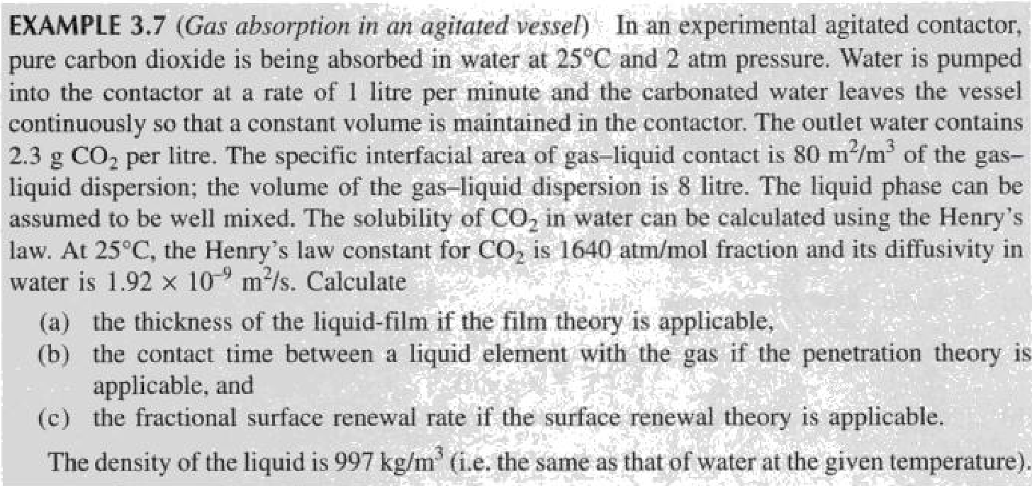

**Ex.3.8 Page no.104**

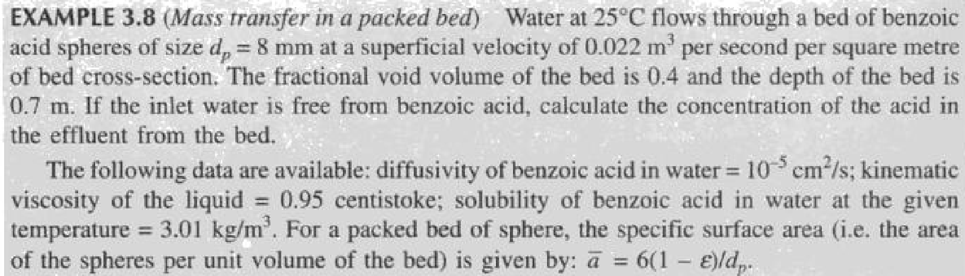

**Ex.3.9 Page no.105**

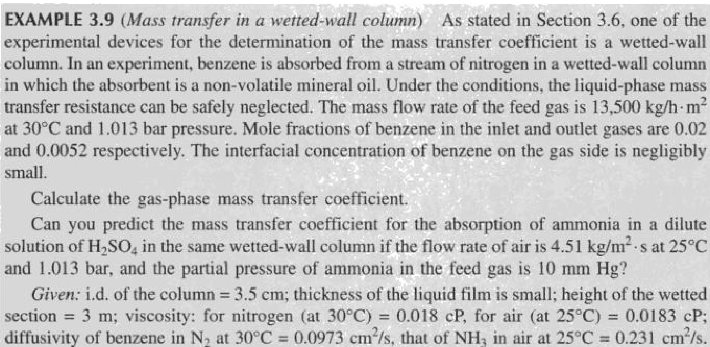

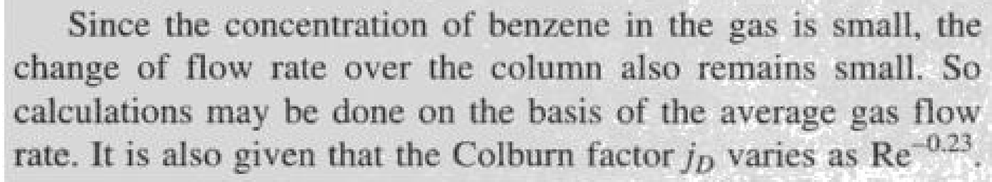

**From book: Treybal**

**Ex. 3.4 page no.69**

What is the heat-transfer analog to this Eq.



**Section 3**

**Unsolved Problems**

**3.1)**A stream of air at 100 kPa pressure and 300 K is flowing on the top surface of a thin flat sheet of solid naphthalene of length 0.2 m with a velocity of 20 m/sec. The other data are:

Mass diffusivity of naphthalene vapor in air = 6 * 10–6 m 2/sec

Kinematic viscosity of air = 1.5 * 10–5 m 2.sc

Concentration of naphthalene at the air-solid naphthalene interface =1 * 10–5 kmol/m3

Calculate:

1. the overage mass transfer coefficient over the flat plate
2. the rate of loss of naphthalene from the surface per unit width

Note: For heat transfer over a flat plate, convective heat transfer coefficient for laminar flow can be calculated by the equation.



you may use analogy between mass and heat transfer

**3.2)** 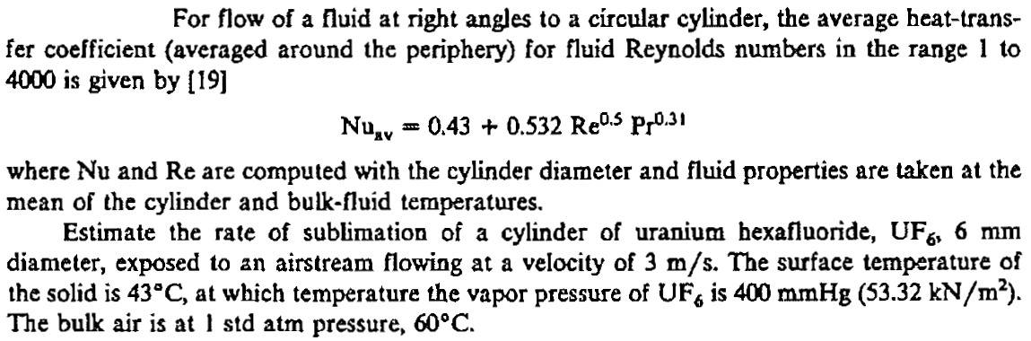

**3.3)** A solid disc of benzoic acid 3 cm in diameter is spin at 20 rpm and 25°C. Calculate the rate of dissolution in a large volume of water. Diffusivity of benzoic acid in water is 1.0 * 10–5 cm2/sec, and solubility is 0.003 g/cc. The following mass transfer correlation is applicable:

Sh = 0.62 Re ½  Sc 1/3

Where  and ω is the angular speed in radians/time.

**3.4)** Air flows over a solid slab of frozen carbon dioxide (dry ice) with an exposed cross-sectional surface area of 1*10-3 m2. The carbon dioxide sublimes into the 2 m/s flowing stream at a total release rate of 2.29 *10-4 mol/s. The air is at 293 K and 1.013* 105 Pa pressure. At that temperature, the diffusivity of carbon dioxide in air is 1.5 *10-5 m2/s and the kinematic viscosity of the air is 1.55*10-5 m2/s.

**3.5)** Determine the Schmidt number for methanol in air at 298 K and 1.013 *105 Pa and in liquid water at 298 K.

**3.6)** Dittus and Boelter proposed the following equation for correlating the heat-transfer coefficient for turbulent flow in a pipe



What should be the corresponding equation for the mass-transfer coefficient when the transfer is to a turbulent fluid flowing in a pipe?

**3.7**) Determine the Schmidt number for

(a) oxygen in air at 300 K and 1.0 atm; and

(b) oxygen in liquid water at 300 K.

At 300 K, the diffusion coefficient of oxygen in liquid water is

1.5*10-9 m2/s.